National Fish and Wildlife Foundation

Gulf Environmental Benefit Fund

Quarterly Progress Report

Easygrants ID: 54029

Project Title: Recovery and Resilience of Oyster Reefs in the Big Bend of Florida

Organization: University of Florida

Project Term: 12/01/2016 – 11/30/2024

Reporting Quarter: April 2019

1. **General statement of project status and implementation.**

This report includes work accomplished during April through June 2019.

Implementation continues to be mostly smooth and the monitoring phase of our project is progressing in a timely fashion.

To date, this project is on track both in budget and within timeline.

**ii. Updates on individual tasks.**

Task 1. Planning and Permitting.

1. Work performed on Task 1.

Subtask 1.1. Mapping and Surveying.

During this period, we have completed RTK GPS elevation surveys on half of the inshore oyster reefs that are comparisons for the Lone Cabbage reef. In addition, we are poised to initiate (July 2019) the first drone based LiDAR surveys of major portions of the study area. This should yield high quality elevation information (to 1 cm accuracy) about many of the reefs in the study area, and allow high resolution elevation maps to be produced. Together, this work establishes survey sites to return to and measure in future years.

Subtask 1.3. Develop engineered plans.

This work was completed and reported on in the October 2017 quarterly report.

Subtask 1.4. Permitting. All construction permits have been reported on, passed by permitting agencies and are considered executed. We retain two active permits that allow for various of the monitoring and research activities.

1. Progress made towards Task 1 milestones.

All permits have been fulfilled and signed off on by permitting agencies, all construction plans have also been fulfilled. Mapping and surveying of the reefs has been accomplished pre and post-construction.

1. Performance of Task I as against the Task 1 Budget.

All subtasks in Task 1 have been completed on schedule, ahead of schedule or are well underway, and we remain within budget. Some of these products are living documents that will require more input as time goes on (e.g., construction monitoring plan, data management plan, water quality sampling plan, biological sampling plan, adaptive management plan).

1. Existing or anticipated problems with implementation of Task 1.

We currently have no existing or anticipated problems with completion of Task 1 and consider this part of the project largely completed.

Task 2. Develop Adaptive Monitoring Plan

1. Work performed on Task 2.

The Adaptive Management Plan for this project should be seen at minimum as a living document, and in reality, as an active, constant process.

The elevation and biological sampling plans continue to evolve as we analyze the first winter season of postconstruction oyster sampling, and ongoing water quality sampling. While we have incorporated all strata into our oyster sampling plan (substrate type, location, treatment, harvest status), the variability displayed by each of the strata was largely unknown as we designed the sampling plan for the first year. The information from the 2018/19 winter season allows estimation of numbers samples required to achieve a known power of detecting change of particular magnitude. This is highly valuable information for ensuing years, and allows us to embark on a detailed design for sampling oysters on inshore and treatment reefs with specific questions in mind. Our current sampling approach is informed by a power analysis using past data collected from the region.

1. Progress made towards Task 2 milestones.

Updating of adaptive management plan, and biological sampling plan.

1. Performance of Task 2 as against the Task 2 Budget.

Task 2 appears to be well within the timeline and budget as set out in the proposal.

1. Existing or anticipated problems with implementation of Task 2.

We do not anticipate any problems with implementation of Task 2. See above uncertainty analysis.

Task 3. Preconstruction Monitoring

1. Work performed on Task 3.

Subtask 3.1. Preconstruction biological monitoring. This reporting period was the first one that was entirely during the post-construction phase, and any sampling during this period technically is not pre-construction. However, during this reporting period we have continued to monitor spat settlement on standardized tiles at fixed water quality sampling stations as an indicator of monthly oyster reproductive activity (Figure 10), which has spanned pre-, during, and post-construction periods. See Figure 10.

Subtask 3.2. Preconstruction and postconstruction elevation profiles of project reefs. This work was accomplished by a professional survey team during the preconstruction period. As under Subtask 1.1, we are initiating drone based elevation surveys of many of the reefs, providing much higher resolution for understanding oyster reef responses.

Subtask 3.3. Water quality sampling. We have continued the water quality sampling program, collecting continuous information and downloading sondes every two weeks (see Figures 2 – 9). We have developed a relational database to track these data and to develop relationships between water quality data, survey information, and oyster populations (Task 7). Water quality and other information from this project is publicly available on the website <http://www.wec.ufl.edu/oysterproject/restoration.php> (click on Additional Information and then the link) and summarized at <https://lcroysterproject.github.io/oysterproject/> .

1. Progress made towards Task 3 milestones.

Pre- and post-construction elevation surveys complete for all constructed reefs; ongoing elevation surveys by drone to expand coverage.

Continued monitoring of water quality around the project reef.

Maintenance of a monitoring and maintenance schedule for water quality information. Coordination of water sampling program with final phases of active construction.

Maintenance of spat settlement sampling grid

1. Performance of Task 3 as against the Task 3 Budget.

This task appears to be well within budget and the schedule of spending as identified in the proposal.

1. Existing or anticipated problems with implementation of Task 3.

No anticipated problems with implementation of this task.

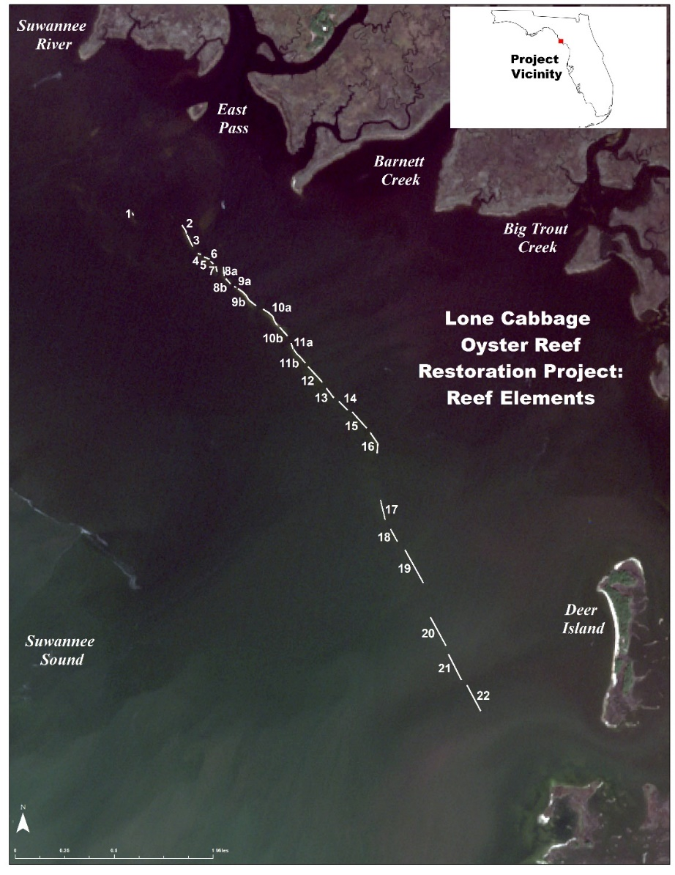

Figure 1. Map of the project area, showing individual reef elements 2 – 22, and surrounding creeks and landforms.

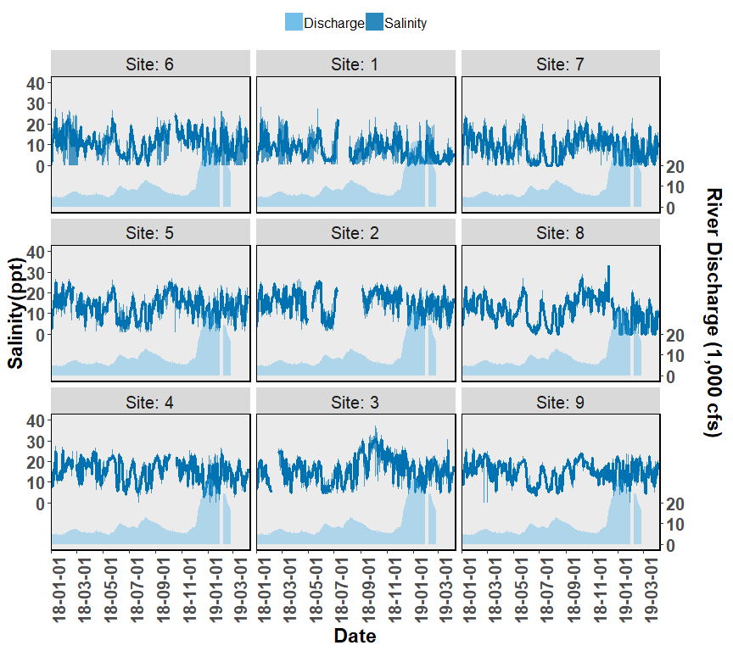

Figure 2. Salinity and discharge data collected from autonomous sensors from the Lone Cabbage Reef restoration site near Suwannee, FL. Each graph represents a sensor location, with top of page as north, and right of page as east. The center column of figures (Sites 1-3) represent the eastern side of the Lone Cabbage Reef restoration site. The left column of figures (Sites 4-6) represent the western side of the Lone Cabbage Reef restoration site. The right column of figures (Sites 7-9) represent sensors close to shore in an area where salinity may be influenced by restoring Lone Cabbage Reef. The first two columns from the west (Sites 1-6) represent the inshore and offshore sides of the restoration reef. The primary y-axis is Salinity (ppt, parts per thousand), and the secondary y-axis is Suwannee River discharge (CFS, cubic feet per second) measured at USGS Wilcox station 02323500 on the Suwannee River. River discharge is graphed as a daily mean in the light blue filled shape near the bottom of each graph. Daily mean Salinity values (dark blue line) are shown in the center of each graph. The shaded dark blue region of the Salinity values are minimum and maximum values of that date. Missing values are provisional data that have not been finalized or represent periods of time when sensors were not yet deployed or off line due to user error or vandalism.

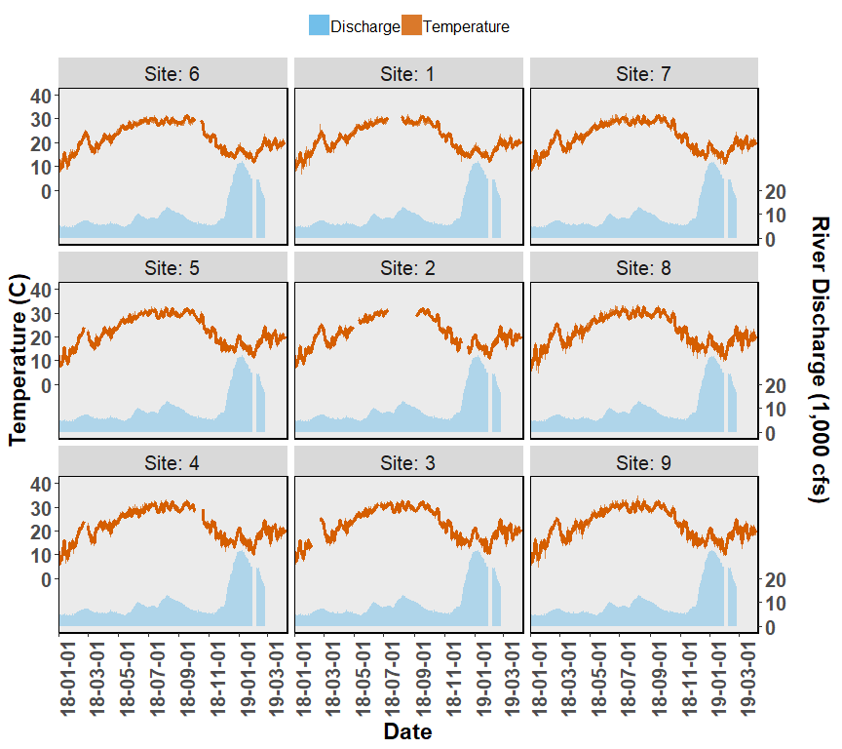

Figure 3. Temperature and discharge data collected from autonomous sensors from the Lone Cabbage Reef restoration site near Suwannee, FL. Each graph represents a sensor location, with top of page as north, and right of page as east. The center column of figures (Sites 1-3) represent the eastern side of the Lone Cabbage Reef restoration site. The left column of figures (Sites 4-6) represent the western side of the Lone Cabbage Reef restoration site. The right column of figures (Sites 7-9) represent sensors close to shore in an area where salinity may be influenced by restoring Lone Cabbage Reef. The first two columns from the west (Sites 1-6) represent the inshore and offshore sides of the restoration reef. The primary y-axis is Temperature (C, Celsius), and the secondary y-axis is Suwannee River discharge (CFS, cubic feet per second) measured at USGS Wilcox station 02323500 on the Suwannee River. River discharge is graphed as a daily mean in the light blue filled shape near the bottom of each graph. Daily mean Temperature values (orange line) are shown in the center of each graph. The shaded orange region of the Temperature values are minimum and maximum values of that date. Missing values are provisional data that have not been finalized or represent periods of time when sensors were not yet deployed or off line due to user error or vandalism.

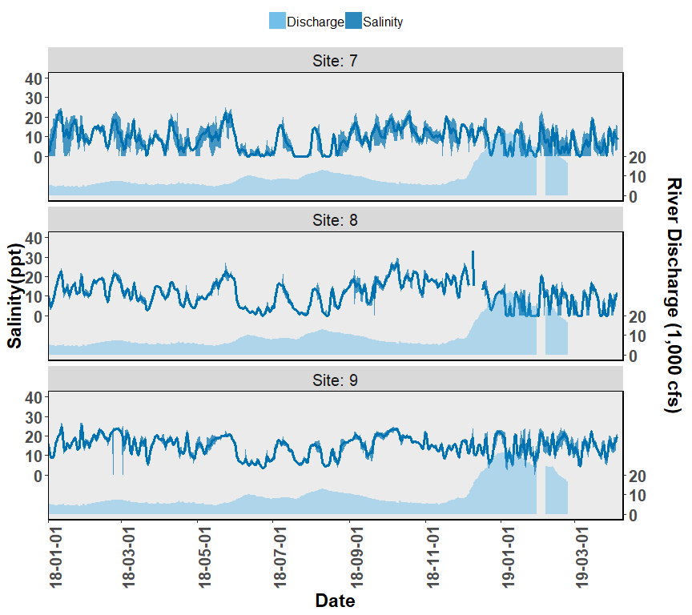

Figure 4. Salinity and discharge data collected from autonomous sensors from the Lone Cabbage Reef restoration site near Suwannee, FL. Each graph represents a sensor location, with top of page as north, and right of page as east. The figures (Sites 7-9) represent sensors close to shore in an area where salinity may be influenced by restoring Lone Cabbage Reef. The primary y-axis is Salinity (ppt, parts per thousand), and the secondary y-axis is Suwannee River discharge (CFS, cubic feet per second) measured at USGS Wilcox station 02323500 on the Suwannee River. River discharge is graphed as a daily mean in the light blue filled shape near the bottom of each graph. Daily mean Salinity values (dark blue line) are shown in the center of each graph. The shaded dark blue region of the Salinity values are minimum and maximum values of that date. Missing values are provisional data that have not been finalized or represent periods of time when sensors were not yet deployed or off line due to user error or vandalism.

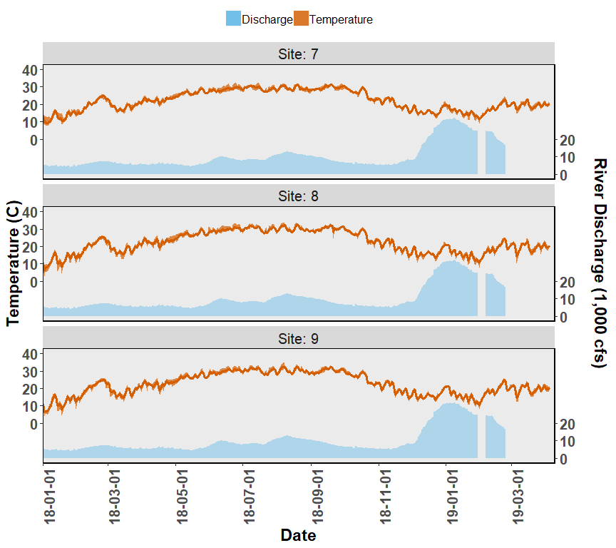

Figure 5. Temperature and discharge data collected from autonomous sensors from the Lone Cabbage Reef restoration site near Suwannee, FL. Each graph represents a sensor location, with top of page as north, and right of page as east. The figures (Sites 7-9) represent sensors close to shore in an area where salinity may be influenced by restoring Lone Cabbage Reef. The primary y-axis is Temperature (C, Celsius), and the secondary y-axis is Suwannee River discharge (CFS, cubic feet per second) measured at USGS Wilcox station 02323500 on the Suwannee River. River discharge is graphed as a daily mean in the light blue filled shape near the bottom of each graph. Daily mean Temperature values (orange line) are shown in the center of each graph. The shaded orange region of the Temperature values are minimum and maximum values of that date. Missing values are provisional data that have not been finalized or represent periods of time when sensors were not yet deployed or off line due to user error or vandalism.

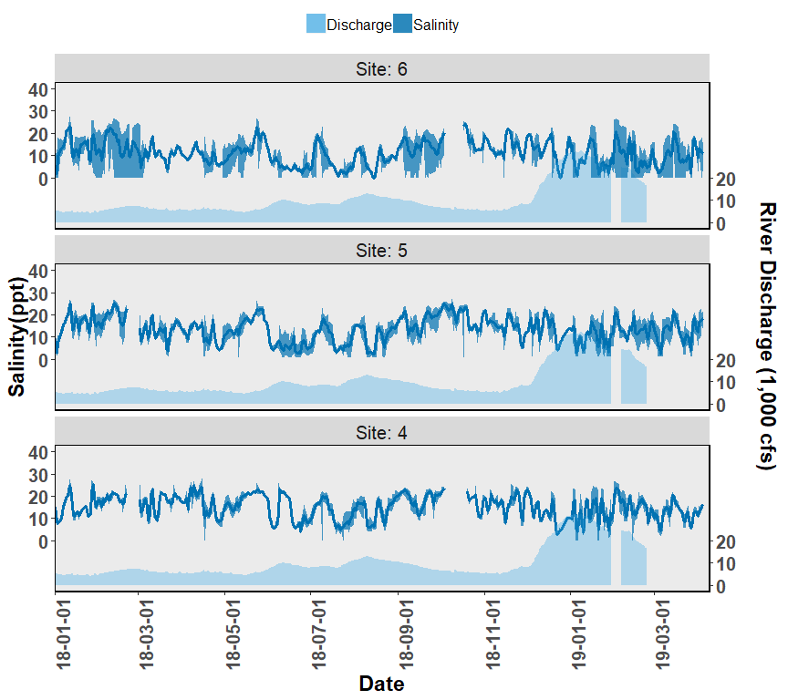

Figure 6. Salinity and discharge data collected from autonomous sensors from the Lone Cabbage Reef restoration site near Suwannee, FL. Each graph represents a sensor location, with top of page as north, and right of page as east. The figures (Sites 4-6) represent the western side of the Lone Cabbage Reef restoration site. The primary y-axis is Salinity (ppt, parts per thousand), and the secondary y-axis is Suwannee River discharge (CFS, cubic feet per second) measured at USGS Wilcox station 02323500 on the Suwannee River. River discharge is graphed as a daily mean in the light blue filled shape near the bottom of each graph. Daily mean Salinity values (dark blue line) are shown in the center of each graph. The shaded dark blue region of the Salinity values are minimum and maximum values of that date. Missing values are provisional data that have not been finalized or represent periods of time when sensors were not yet deployed or off line due to user error or vandalism.

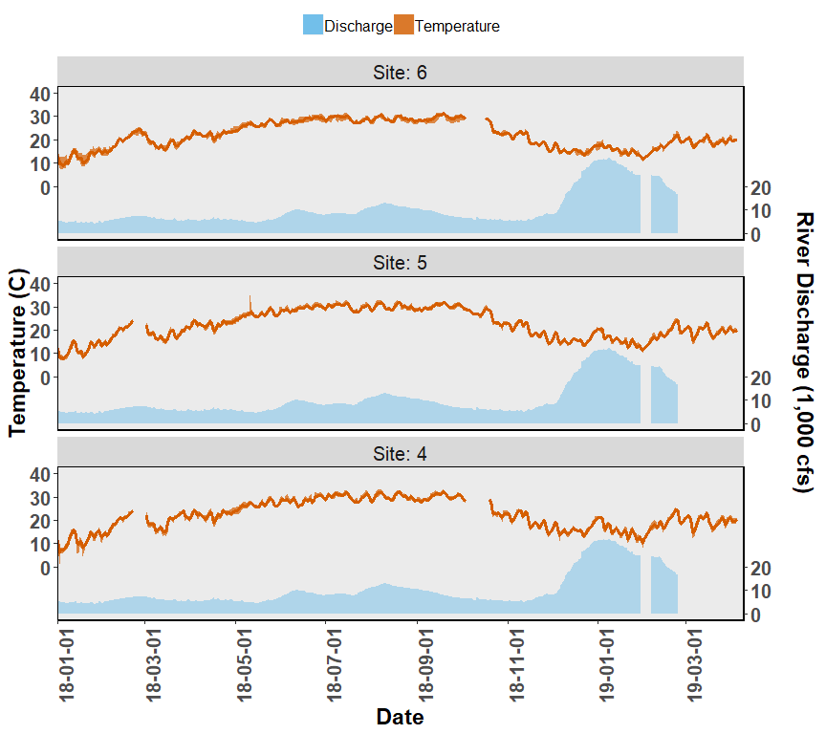

Figure 7. Temperature and discharge data collected from autonomous sensors from the Lone Cabbage Reef restoration site near Suwannee, FL. Each graph represents a sensor location, with top of page as north, and right of page as east. The figures (Sites 4-6) represent the western side of the Lone Cabbage Reef restoration site. The primary y-axis is Temperature (C, Celsius), and the secondary y-axis is Suwannee River discharge (CFS, cubic feet per second) measured at USGS Wilcox station 02323500 on the Suwannee River. River discharge is graphed as a daily mean in the light blue filled shape near the bottom of each graph. Daily mean Temperature values (orange line) are shown in the center of each graph. The shaded orange region of the Temperature values are minimum and maximum values of that date. Missing values are provisional data that have not been finalized or represent periods of time when sensors were not yet deployed or off line due to user error or vandalism.

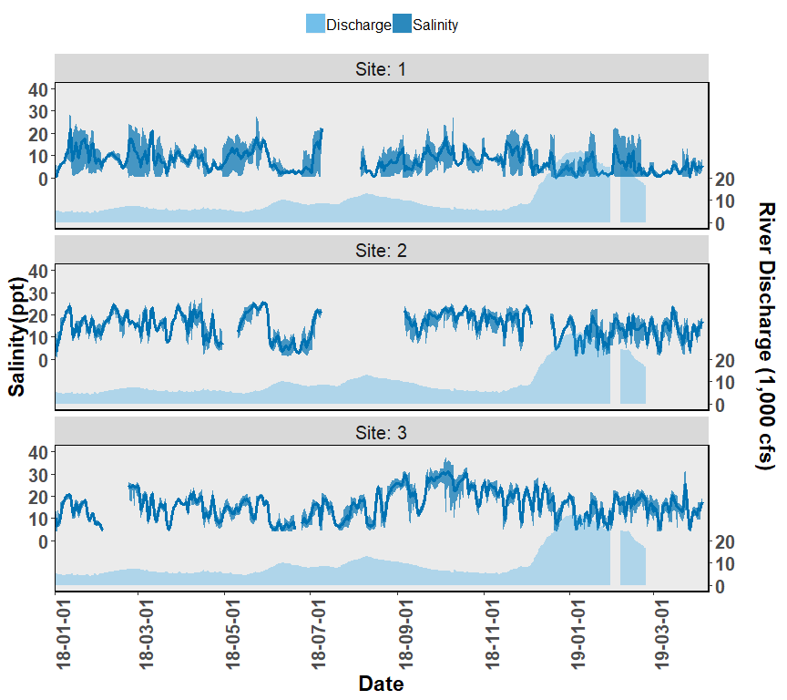

Figure 8. Salinity and discharge data collected from autonomous sensors from the Lone Cabbage Reef restoration site near Suwannee, FL. The figures (Sites 1-3) represent the eastern side of the Lone Cabbage Reef restoration site. The primary y-axis is Salinity (ppt, parts per thousand), and the secondary y-axis is Suwannee River discharge (CFS, cubic feet per second) measured at USGS Wilcox station 02323500 on the Suwannee River. River discharge is graphed as a daily mean in the light blue filled shape near the bottom of each graph. Daily mean Salinity values (dark blue line) are shown in the center of each graph. The shaded dark blue region of the Salinity values are minimum and maximum values of that date. Missing values are provisional data that have not been finalized or represent periods of time when sensors were not yet deployed or off line due to user error or vandalism.

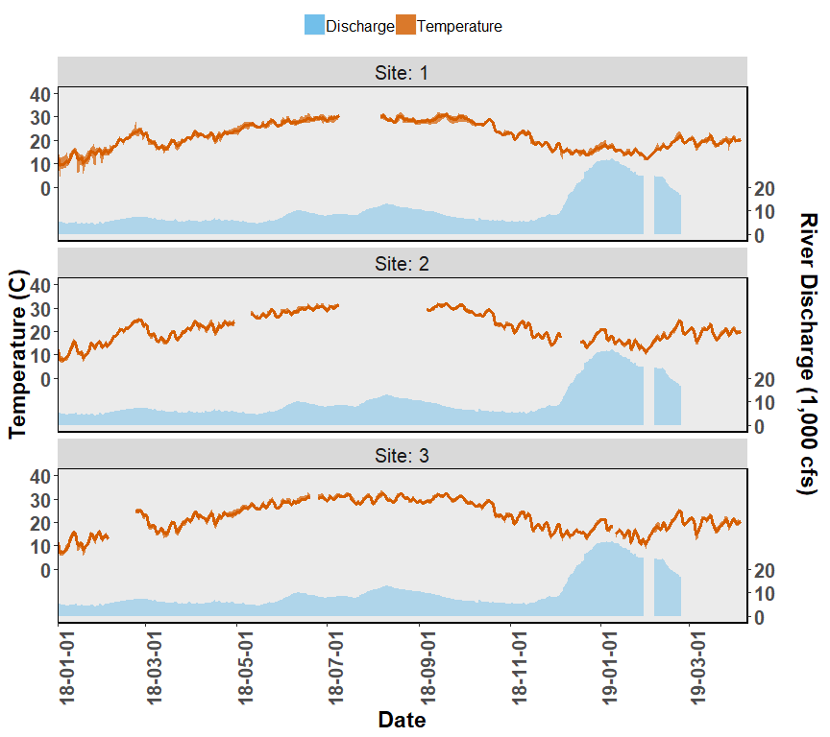

Figure 9. Temperature and discharge data collected from autonomous sensors from the Lone Cabbage Reef restoration site near Suwannee, FL. The figures (Sites 1-3) represent the eastern side of the Lone Cabbage Reef restoration site. The primary y-axis is Temperature (C, Celsius), and the secondary y-axis is Suwannee River discharge (CFS, cubic feet per second) measured at USGS Wilcox station 02323500 on the Suwannee River. River discharge is graphed as a daily mean in the light blue filled shape near the bottom of each graph. Daily mean Temperature values (orange line) are shown in the center of each graph. The shaded orange region of the Temperature values are minimum and maximum values of that date. Missing values are provisional data that have not been finalized or represent periods of time when sensors were not yet deployed or off line due to user error or vandalism.

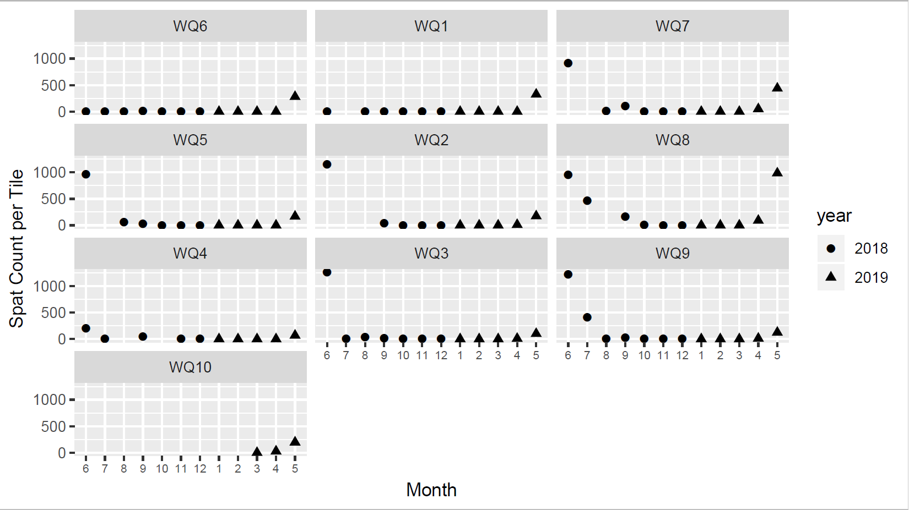 Figure 10. Monthly oyster spat totals on oyster shell and tile spat collectors deployed at each of the water quality monitoring stations throughout the project area, during 2018 and 2019. Shell totals are converted to spat per kg shell, and tile totals are spat per tile (0.107m2). Both shell and tile spat collectors were used during summer 2018 before switching to only using tiles in October 2018. Shell and tile spat collector counts are shown for the same time periods for comparison.

Task 4. Construction

1. Work performed on Task 4. All construction activities were completed by November of 2018, so no new work is reported here on construction activities.

Subtask 4.1. Development of construction documents. This subtask was completed as of the April 2018 quarterly report.

Subtask 4.2. Development of construction contracts. This task was completed during the last two reporting periods. All construction contracts are now fulfilled.

Subtask 4.3. Preparation of reef construction footprints. This work was completed during the last reporting period.

Subtask 4.4. Monitoring of construction.

Subtask 4.5. Post-construction activity and inspections. This work was completed prior to this reporting period.

Progress made towards Task 4 milestones.

All aspects of reef construction completed as of November 30, 2018.

All permit inspections have been passed,

1. Performance of Task 4 as against the Task 4 Budget.

This task has been completed on schedule, and within budget.

1. Existing or anticipated problems with implementation of Task 4.

No problems are anticipated with the implementation of Task 4, which is complete.

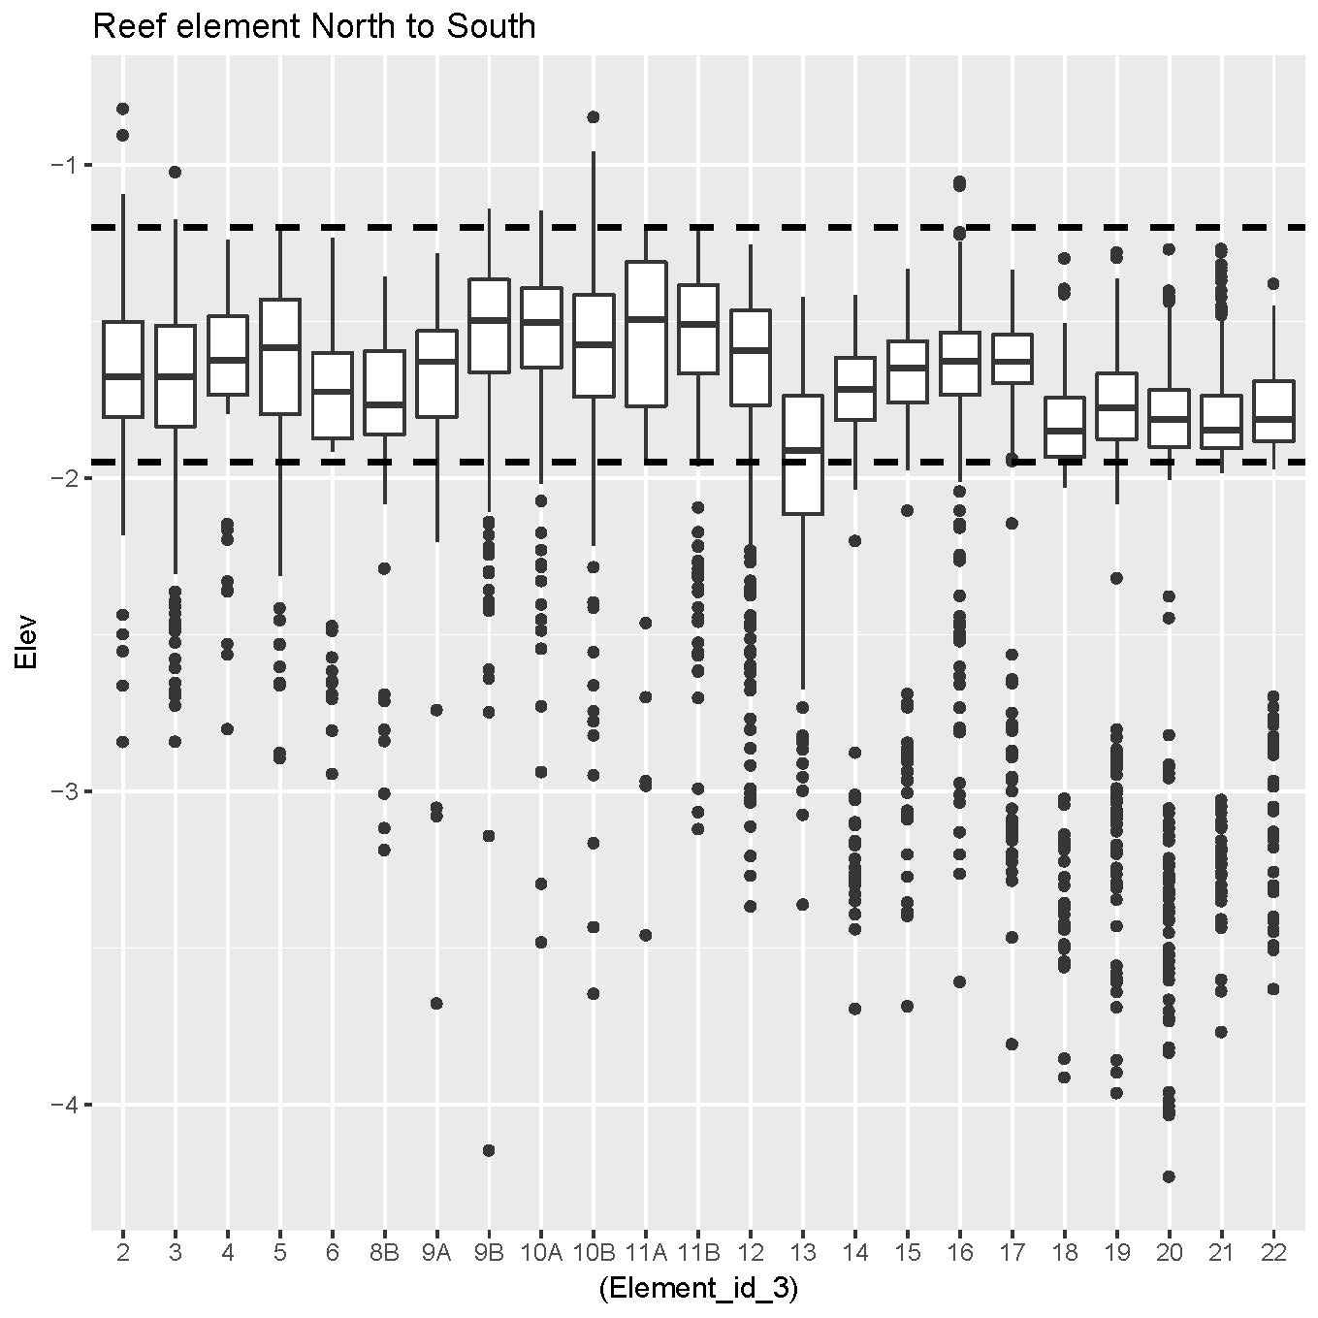

Figure 11. Box plots of elevation (feet NAVD 88, Y axis) at individual reef elements (x-axis) on Lone Cabbage Reef based on survey points collected at the top of individual rocks placed on the reef. The dashed horizontal lines represent the range of acceptable target elevations from the construction specifications.

Task 5.

1. Post-construction monitoring.

Work performed on Task 5. We have continued water quality and spat monitoring during the reporting period (see Figures 2 – 10). We have also completed the first round of post-construction monitoring of oyster densities and sizes both on the Lone Cabbage Reef and at inshore sites.

We have targeted winter sampling as the primary season for annual evaluation for two reasons. First, this is when eustatic sea level and tides are at their lowest, and the intertidal reefs are most available for sampling. Second, considerable evidence suggests that winter population sizes are relatively stable, at least as compared with the growing season, which shows wide fluctuations in survival and recruitment due to a number of factors. Our most common sampling method is total counts within permanent, defined belt transects of variable length, 15.25 cm wide (see pictures in Uploads). Transects are counted annually, and defined by permanently marked start and end points. Transects are defined during counting by erecting four strings that allow observers to unambiguously detect the edges of transects. Transects are oriented either along the long axis of the reef (Lone Cabbage) or in randomized cardinal directions at inshore reefs (see Figure 12). Sampling of oysters is designed to answer two questions –

1. Are there more oysters and are they of a different size distribution on Lone Cabbage Reef before vs after construction/restoration. This compares line transect counts and size distribution samples in the same locations before and after addition of the rock and oyster shell treatment. The post-construction sampling has been completed for the 2018/9 season at 18 22-meter long belt transects 15.25 cm wide on four different reef elements sampled before (November 2017) and after (December 2018) the construction. The December sample was only barely a month after the last of the construction was completed, and probably too little time to see much of a response by colonizing oysters. Nonetheless there are numerous small oysters evident on the reef especially in tight spaces between rocks and shell that have become established only in the short time post-construction (see pictures in Uploads).
2. Are oyster count and size dynamics on Lone Cabbage Reef being mimicked by oysters at inshore areas? This question gets at the possible telegraphic influence of the Lone Cabbage Reef restoration on inshore reefs, through the hypothesized effect of the reef on salinities. This sampling involves using the same belt transect count method as Question 1 (above). For this question we are accounting for physical and management differences by dividing reefs up into strata, and then placing transects on those strata in proportion to the availability or acreage of the strata. The strata are: rock/no rock, large rock, small rock, and presence or absence of oyster harvest (approximately one third of the constructed reef area is within a harvest zone). Initially we have sampled a total of 110 transects totaling 2,530 meters, of which we have finished sampling on 100% to date.

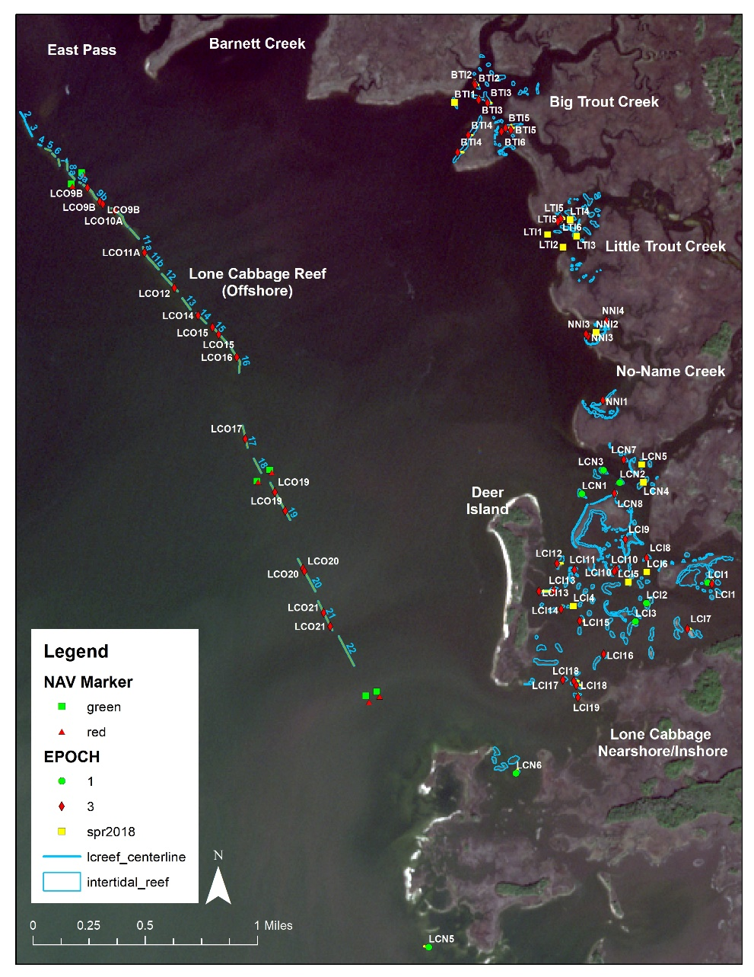

Figure 12. Map of the Lone Cabbage reef and surrounding area showing locations of oyster density transects by previous sampling (“Epoch 1 & 3”), and outlines of reefs proposed for sampling in winter 2018/19.

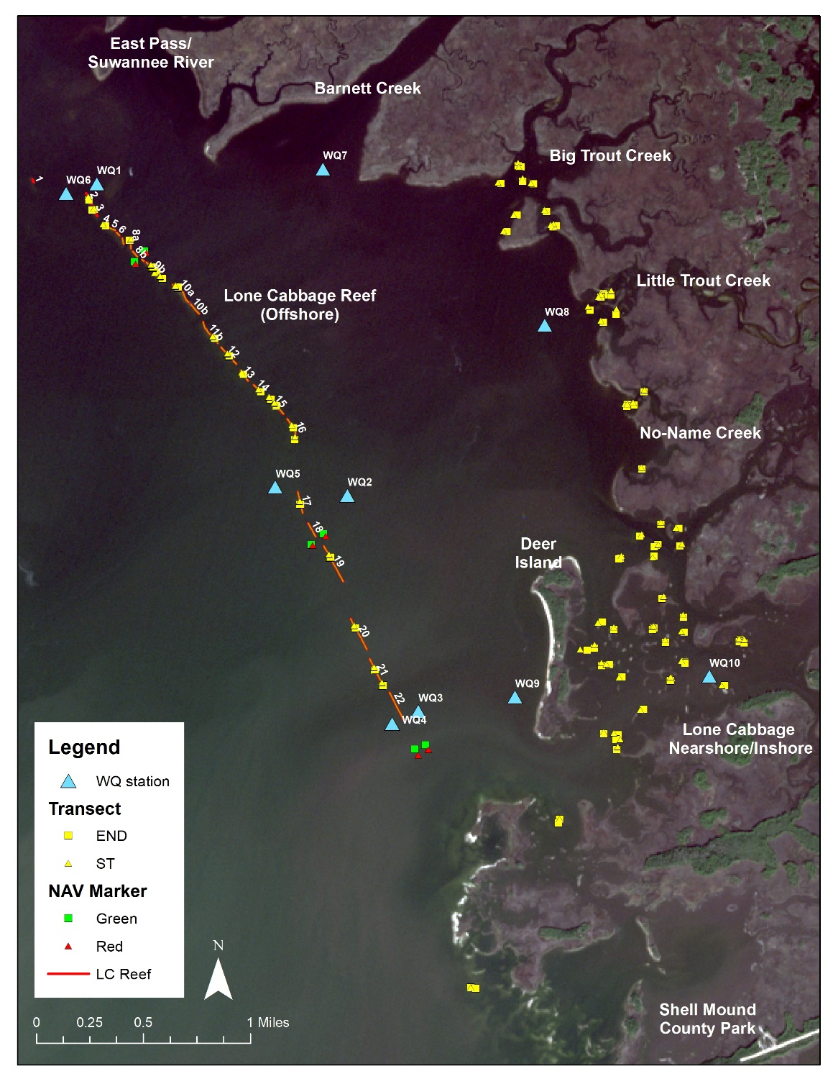

Figure 13. Locations of oyster sampling transects sampled during winter 2018/19. In total, 61 transects were sampled for a total of 2,620 meters (1.63 miles) of transects.

We have also attempted to measure and control for interobserver error as much as possible, since this is typically a large source of measurement error in field counts of oysters and other sessile but numerous organisms. We have used “paper rock” mockups to estimate observer error and bias in estimating oysters and used this as a tool to select our best counters, and to consider this as another source of variation to account for in our assessment of trends in oyster counts. A subsample of transects were also counted twice by different counters in order to assess interobserver variability in oyster counts in the field.

We have also initiated the post-construction aspects of our elevation sampling plan. In addition to the several hundred points established during professional surveys pre and post-construction on the LC reef (Task 1, see Figure 11), we have also established long term monitoring points on the permanent transects that we are using for oyster counts at inshore sites. All elevations are established using survey grade RTK GPS equipment, with an accuracy of 2-3 cm in the vertical plane. On the transects, points are taken every 2.5 meters along the axis of the transect to match oyster count sampling intervals and to develop a cross-sectional profile of each sampled reef. Elevation monitoring will be accomplished annually during winter months at all stations. We have finished surveying most of the sampling sites at the comparison reefs during this reporting period. As above (Subtask 1.1), we are collaborating with Dr. Ben Wilkinson (UF Geomatics) for drone based LiDAR surveys of the entire study area, to be initiated July 2019 and finished in winter 2019/20. This should yield high quality GIS information about all the reefs in the study area, and allow high resolution elevation maps to be produced. Together, this work establishes survey sites to return to and measure in future years.

B. Progress made towards Task 5 milestones.

Completion of monitoring elevation, biological response, and water quality monitoring plans.

Postconstruction biological sampling of oyster density and size on all study reefs completed.

The postconstruction elevation sampling plan has been completed for the first round of postconstruction sampling.

C. Performance of Task 5 as against the Task 5 Budget.

This task is within schedule and budget.

D. Existing or anticipated problems with implementation of Task 5.

We do not anticipate any major problems with the implementation of Task 5. The largest uncertainty at the moment is whether the variation in oyster counts within our sampling system will be within a range that will result in acceptable statistical power. While we have some ability to expand sampling to accommodate high variation in counts, we are working close to the limits of manpower and tidal availability.

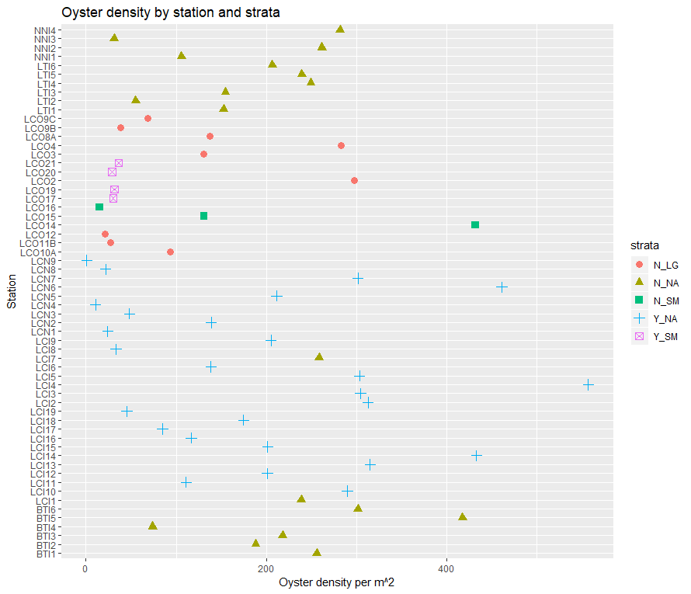

Figure 14. Density of oysters at locations sampled in winter 2018/19, by strata. N_LG = no harvest zone, large rocks on Lone Cabbage reef, N_NA = no harvest zone, inshore unrestored site, N_SM = no harvest small rock size on Lone Cabbage reef, Y_NA = harvest zone, inshore unrestored site and Y_SM = harvest zone, small rocks on Lone Cabbage reef. Note the wide variation in densities within nearly all strata.

Task 6. Outreach and Education

1. Work performed on Task 6.

Subtask 6.1. Preconstruction outreach and education.

Since construction has been completed, this subtask has been completed and there is no new information to report.

Subtask 6.2. Post-construction education and outreach.

Our brochure about the project continues to be distributed to the public via the local hardware and tackle shops, marinas, the Cedar Key Chamber of Commerce, and two biological stations during the reporting period.

We maintain 3 public educational displays about the Lone Cabbage restoration project at high traffic boat ramps in Cedar Key and Suwannee.

We continue to update public information about the project on the project website http://www.wec.ufl.edu/oysterproject/, and the project list-serve, and through the various electronic and social media produced by the Nature Coast Biological Station in Cedar Key <https://ncbs.ifas.ufl.edu/>. An update on the project was published in the Nature Coast Biological Station newsletter in early July 2019 (see <https://mailchi.mp/6cf6ef8163a2/monthly-newsletter-2028677?e=d4399ed8e2>. Data can be seen by the public for water quality and other preconstruction data via the “Additional Information Tab” of our project website (<http://www.wec.ufl.edu/oysterproject/>). Approximately 7 hours per month of server time is used to support the interactive water quality graphs. This time is based on the “active clicking” of the maps by visitors to the site, and not simply displaying the maps on the computer screen.

During this reporting period, we have also made an invited presentation about this project to a group of business leaders and political advisors in Tallahassee, FL.

1. Progress made towards Task 6 milestones.

Maintenance of public educational displays for three boat ramp areas, maintenance of public safety notices at three launch ramps, maintenance of the website and listserve, and regular posting of information on NCBS websites.

1. Performance of Task 6 as against the Task 6 Budget.

This task appears to be within the budget proposed and on schedule.

1. Existing or anticipated problems with implementation of Task 6.

We do not anticipate any problems with the implementation of Task 6.

Task 7. Data Management

1. Work performed on Task 7.

Beginning in early Fall 2017 we have worked closely with the UF Library Academic Resource Computing (LARC) team as part of our efforts to develop a database and data management system that will provide secure and long-term storage for data collected as part of this project. We have now completed the first data management plan. We archive notes, experimental products, and test data using Git, secure data for long-term storage following guidelines from UF-IT services, and have fully developed the database system for our water quality data. All oyster count data are stored in data tables and data entered using a double-data entry system with pull-down menus to minimize data entry errors. These data tables will be joined to the water quality data in 2019. We have also included elevation and geospatial data in this management system and recently developed a standard format for storage and naming of these data.

We have uploaded water quality data collected since August 2017 into this database and we update the database with new data files each time data are download from the sensors, approximately every 10-14 days. We use both automated and manual error checking routines on these data at the import and export levels. We are continuing to work with LARC to develop a compatible system at lower cost for the oyster field data and have a prototype system in place. We are now working towards a similar system for elevation data, and hope to be able to join databases using location information in the near future. Database and version control will require continuous maintenance as new data are available and analyses conducted. Our current data management system for water quality allows us to provide simple visualizations of our water quality data to the public via the “Additional Information Tab” of our project website (<http://www.wec.ufl.edu/oysterproject/>). These visualizations of temporal patterns in river discharge, temperature, and salinity across Suwannee Sound have been of interest to cooperating management agencies, the general public, and specific user groups such as recreational fishing guides.

1. Progress made towards Task 7 milestones.

Database structure is mostly finished for water quality, and is in development for biological sampling and for elevation sampling.

1. Performance of Task 7 as against the Task 7 Budget.

We are currently proceeding as scheduled for Task 7 and are within budget.

1. Existing or anticipated problems with implementation of Task 7.

None anticipated.

Task 8. Project Administration.

1. Work performed on Task 8.

Subtask 8.1. Tracking expenditures.

The project budget tracking appears to be working well, and we have had no issues with this since December 2017. We have now had eight fiscal reports which (with some fine tuning) have produced reports that are acceptable to NFWF. The process seems to be getting easier, especially as we have now instituted a policy that all expenditures be entered with the title that corresponds to each line item within the budget. We have now initiated a one-year internal audit (October annually) to summarize annual expenditures on this project in detail.

Subtask 8.2. Managing staff.

In addition to long-standing Field Coordinator Steve Beck, new field technician Arik Hartmann worked with us through May of 2019, when he moved to a graduate program and was replaced by Tyler Ring. Mel Moreno continues to work on data management and real time data portrayal for the project. Graduate student Annalee Tweitman is now capable of leading field work trips, and is carrying on an ambitious project on salinity/elevation effects on oyster growth and survival. Tyler Coleman is a new PhD student working with us on oyster research, and will also be a frequent member of the field team. PhD student Kwanmok Kim is working on understanding the role of interstitial space in oyster survival in the Big Bend waters. In summer 2019 we have trained and incorporated summer NCBS interns Caroline Barnett and Samantha Hoskins, who have worked on lab and field aspects of the project for about two months each. We expect the latter positions will be ongoing since data management and field collection work will only grow as the project proceeds. We have supported or leveraged up to 7 new graduate students who are working wholly or at least peripherally on this project, starting in August 2018. Their projects will range from sampling and design questions, to understanding biological processes like predation, to understanding the role of physical structure in oyster survival, to linking oyster productivity with fisheries practices. We are also been able to include 12 undergraduate or high school students in our programs during this quarter. We continue to be engaged with several students or professionals outside of this project who are working on modeling the community/trophic dynamics of oyster reef and nearshore communities in relation to physical forcing functions like freshwater flow, salinity and fisheries pressure.

Subtask 8.3. Coordination.

Coordination has been carried out through weekly and as-needed meetings and communications among the three principal investigators, and the research coordinator and student OPS workers. We also meet 1 – 2 times biweekly with personnel associated with the UF Libraries data management group (LARC) as we fine-tune the data management system for this project.

Coordination activities with projects external to this one have included coordination with county plans for additional oyster restoration activities (Sturmer, Frederick), coordination with research planned for the Lower Suwannee National Wildlife Refuge hydrological restoration project (Pine, Frederick), antipoaching activities and oyster management by the Florida Fish and Wildlife Conservation Commission (Frederick, Pine, Sturmer), coordination with plans to sample fishes on the Lone Cabbage Reef by Nature Coast Biological Station and the Florida Fish and Wildlife Conservation Commission (Pine, Frederick), coordination with aquaculture activities in the area (Sturmer), and coordination with Florida’s Oyster Integrated Mapping and Monitoring Program (OIMMP, Pine and Beck). We are also actively pursuing a number of different grants with collaborators who are interested in leveraging the Lone Cabbage Reef experiment to better understand upstream land use linkages with coastal ecology and fisheries. Dr. Frederick has recently engaged in a cooperative plan to accomplish drone based LiDAR surveys of the study area (as above).

Subtask 8.4. Reporting. During this period we have submitted requests for reimbursement for the April 2019 reporting period, and have completed the quarterly report for the April through June 2019 period.

1. Progress made towards Task 8 milestones.

Fiscal reports and requests for reimbursement completed for April 2019.

Quarterly report completed for April through June 2019.

Management and training of research coordinator, graduate students and OPS student workers.

Internal coordination of this project among staff and PI’s, four UF departments, Nature Coast Biological Station and UF PDC.

External coordination of this project with 1 federal agency, two state agencies, local aquaculture practitioners, the Contract Manager and subcontractors.

Completion of a grant proposal that could significantly leverage the products and learning of this project.

1. Performance of Task 8 as against the Task 8 Budget.

This Task appears to be within the Task 8 budget, and on schedule.

1. Existing or anticipated problems with implementation of Task 8.

We are currently not experiencing significant problems with administration of this project.

**2) Submission schedule for payment requests.**  UF has submitted payment requests in July and October 2017, January, April, July, October and December 2018, January 2019, and we plan to continue submissions on a quarterly basis.

**3**) **Any other information necessary for NFWF’s evaluation of the Project’s progress as measured against the Project Description, Budget, and Project schedule.** We do not have any other information that might help NFWF evaluate the project’s progress, other than products listed under **4**) below.

1. **Project products and deliverables produced during the applicable reporting period.**

See attached or in Uploads for this report: